<https://www.server-world.info/en/note?os=CentOS_7&p=haproxy>

**. Open Haproxy config file**

vi /etc/haproxy/haproxy.cfg

**. Need to add log type (info, warn, error etc)**

log 127.0.0.1 local2 info



**. Make sure that the following parameter present in haproxy.cfg file**



**. Need to create a rsyslog’s config file for HAProxy**

**. Create a new file /etc/rsyslog.d/haproxy.conf with following content:**

[root@kubernetes-worker3 rsyslog.d]# vi haproxy.conf

# line 15,16: uncomment, lne 17: add

$ModLoad imudp

$UDPServerRun 514

$AllowedSender UDP, 127.0.0.1

# line 54: change like follows

*.info;mail.none;authpriv.none;cron.none,local2.none /var/log/messages

local2.* /var/log/haproxy.log

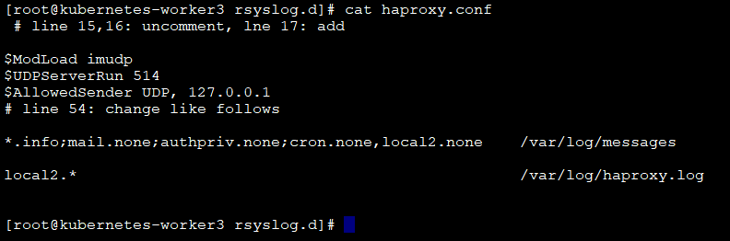

**. Restart haproxy & rsyslog service**

systemctl restart haproxy

systemctl restart rsyslog

**. Check log from /var/log folder**

